ACT for Meningitis is a national meningitis support and awareness charity, which was set up in 2011.
Our Mission: To raise awareness, to promote education and to provide support to those affected by meningitis in Ireland.
Our Vision: To see an Ireland where lives are no longer lost to Meningitis and through our support services no one faces the meningitis journey alone.
Our Future: To build “Aoibhe’s House, a unique meningitis centre of excellence based in the west of Ireland, providing essential support, vital training and life-saving awareness at a national level.

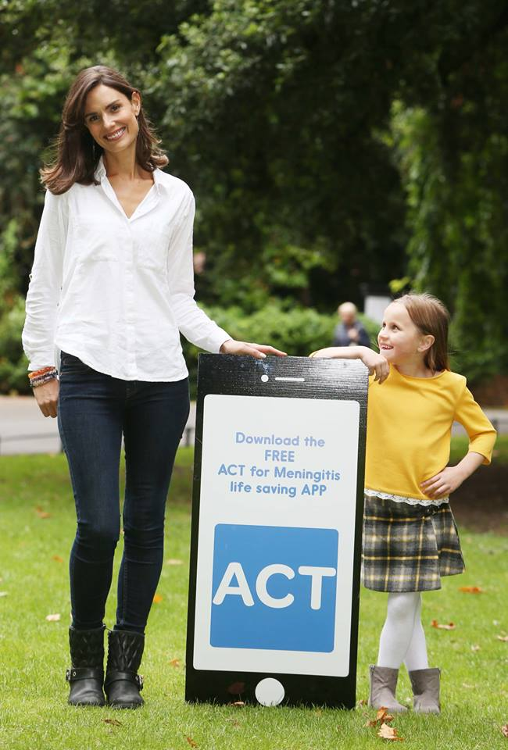

CONTENTS
- Chairperson Foreword
- Chief executive foreword
- About ACT for Meningitis
- Awareness 2016
- Support services 2016
- Fundraising 2016
- Financials
- Independent auditors report
- Board of directors
- Company information
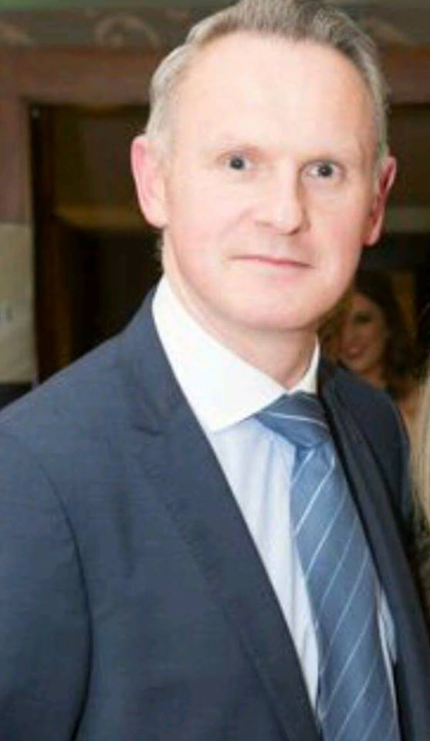
Tim Colleran
Chairperson’s Foreword
It was with great honour that I accepted a position on the ACT for Meningitis board in 2015 and was nominated to Chairman by my fellow board members. To be involved with a charity that is so passionate for and dedicated to their cause is an inspiration. ACT started very much at a local level in Galway but as you will see from our Annual Report it has grown to a national level helping people in 17 counties and reaching beyond that with our awareness campaigns.
The Board and I continue to be inspired by Siobhan and the team in ACT who work tirelessly to make more people across Ireland aware of Meningitis and its effects on lives. They continue to support people and families affected by Meningitis by providing the practical supports and therapies needed. This is all done by a relatively small team in Galway who travel the country to raise awareness of meningitis and help those affected by meningitis.
I would like to take this opportunity on behalf of myself and the board of directors to thank our team for their tireless work and our supporters for your endless commitment to ACT’s cause. You continue to help raise much needed funds which help us provide the network of supports needed to realise our vision “To see an Ireland where lives are no longer lost to Meningitis and through our support services no one faces the meningitis journey alone.”
Tim

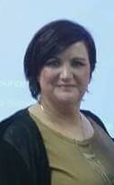
Siobhan Carroll
CEO’s Foreword
Looking back over the last 5 years since we set up ACT for Meningitis in memory of our beautiful 4 year old daughter Aoibhe ,we were just a normal family whose lives changed forever in 2008 and we wanted to do something to prevent others going through what we went through and it has been just an amazing journey so far.The charity is growing from strength to strength and we will keep working until we see an Ireland where lives are no longer lost to Meningitis, and through our support services no-one faces the meningitis journey alone.

One of our proudest days this year was the launch of our life saving Meningitis Awareness App. This free App is available to download on Android and iPhone and at a touch of a button it provides users with the symptoms of Meningitis and gives them instructions for what to do if they suspect Meningitis. We know the new App will save lives in Ireland.

2016 was also in part a challenging year with regards to fundraising and meeting the growing demands of the organisation with the phenomenal growth of our support services resulting in a massive 448% increase in costs. This is expected to grow even more in 2017 as we continue to help people to rebuild their lives after Meningitis.

There was also significant progress made this year with the long-awaited introduction of the Men B vaccine for babies introduced into the Childhood Immunisation Schedule on December 1st in Ireland.

As we look ahead to 2107 we know there is still so much to be done. We are working on our new flyers for hospitals and GP surgeries and also the issues around insufficient follow up care when returning home from hospital after Meningitis. We will continue to work on identifying the needs of those that need support and we will always be here for them.

This year has seen progress made and I would like to acknowledge the continued support of the many friends and supporters of ACT for Meningitis who are making such a difference in the lives of those affected by Meningitis.The year ahead is ambitious as always for the organisation but embrace it we will as we are inspired on a daily basis by the people we meet. I look forward to your continued support in 2017.

Siobhán

About ACT for Meningitis

ACT for Meningitis was set up in 2011 by Siobhan and Noel Carroll following the tragic loss of their daughter Aoibhe, aged just 4, to Meningitis. Losing Aoibhe changed their lives forever and they wanted to try and prevent another family going through that heart break. They felt there was an urgent need for more awareness around Meningitis and that support be made available to anyone affected by the disease, therefore, in July 2011 they set up ACT for Meningitis, with a Mission to raise awareness, to promote education and to provide support to those affected by meningitis in Ireland, and with a vision to see an Ireland where lives are no longer lost to meningitis, and through our support services no-one faces the meningitis journey alone.

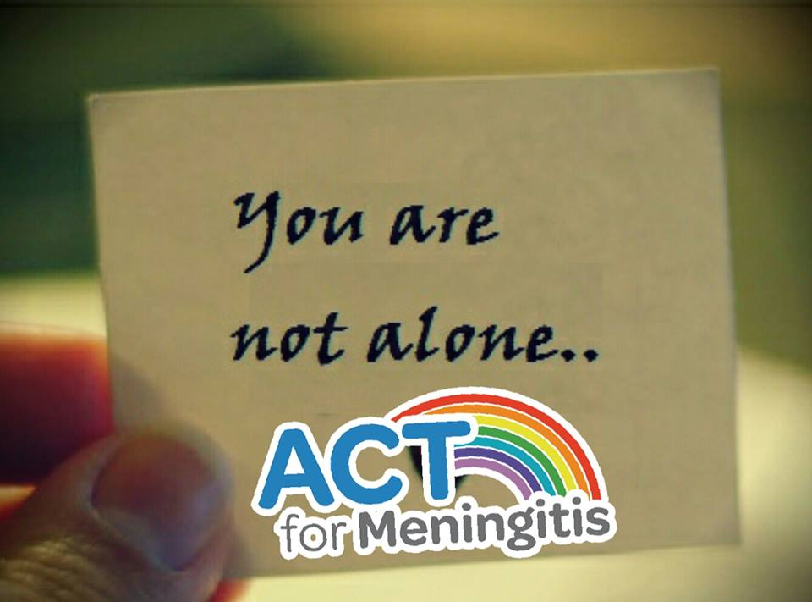

A non-government funded small organisation of just four part-time staff ACT are completely focused on trying to make a big difference. In just 5 short years through self-fundraising ACT have become the only organisation to offer a vast range of free support services to anyone in Ireland affected by Meningitis, either through bereavement of living with the severe after affects of this life-changing disease.

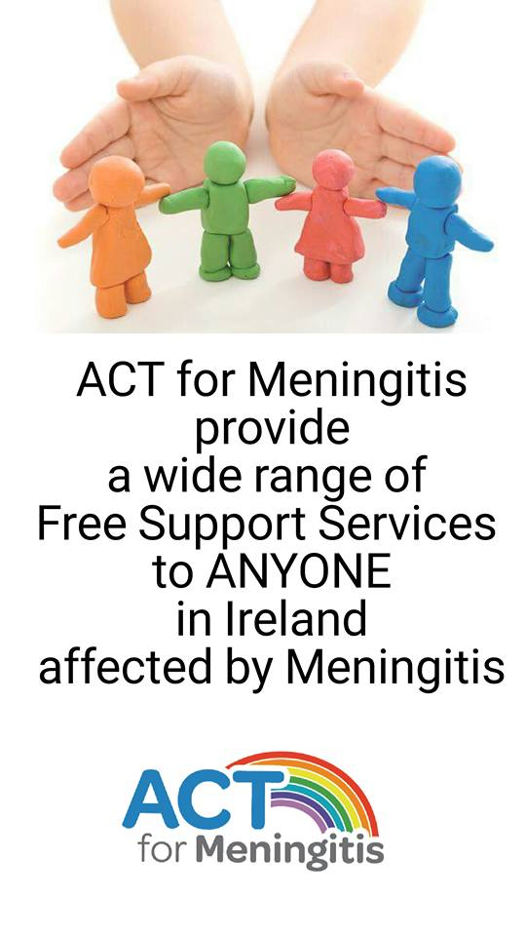
Support Services
Our support services are tailored to the needs of the individual /family to find the most appropriate and beneficial service for them. Meningitis has a wide range of severe side affects coupled with the trauma of the experience and in 1 in 10 cases it tragically results in bereavement. Our trained family support officer assesses where the charity will be most beneficial in providing support.
Our services include creative therapies-including play and art therapy which help children deal with the impact of the disease, free counselling services for families or individuals who have been affected by Meningitis, Cranial Sacral Therapy, physiotherapy ,psychologist assessment, one to one support, and family support days.

Awareness & Education
ACT for Meningitis is committed to raising awareness of the signs and symptoms of Meningitis. To date, we have distributed over 130,000 awareness cards and have held numerous talks and presentations to schools, community groups and the public across the country further supplying numerous facilities, such as universities, crèches, schools, pharmacies and many places of work, with these life-saving cards..

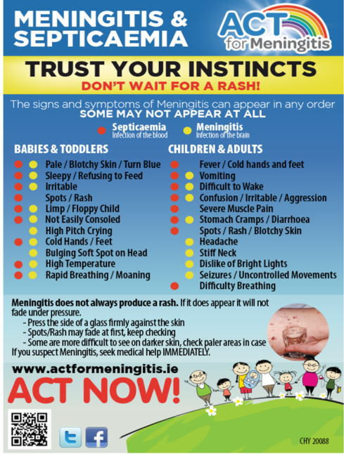

Our various annual national awareness campaigns such as our Student Awareness Campaign, the Winter Warning, our Back-to-School Campaign and ACTion Teds Crèche Campaign enable us to reach thousands of new people every year with awareness. We further continue our awareness raising activities through print, radio and social media campaigns further reaching millions with life saving awareness, and with the availability of our free downloadable ACT for Meningitis Awareness App.

Knowing the signs and symptoms of Meningitis can save a life. ACT for Meningitis will strive to ensure through our awareness and education we can reduce the impact of this disease.

Awareness 2016
2016 was another very successful year with our awareness campaigns. We are continuously reaching new individuals, families and communities across the county with our awareness reaching over 1.5million with our awareness through social media alone this year.

Lloyds Pharmacy Training
We were delighted to have been approached by Lloyds pharmacy to provide meningitis awareness training to over 100 lloyds pharmacists and their “over the counter” team of staff. The training took place in Dublin and limerick over the months of May and June 2016. ACT presented to several groups of pharmacists providing them with a clearer knowledge of meningitis, the signs and symptoms, the various strains and the vaccinations available. We found the training sessions were very interactive, receiving very positive feedback.

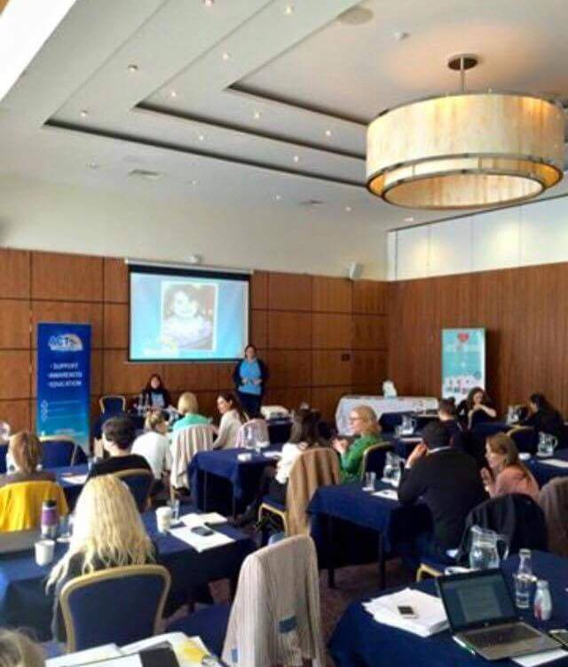

Life Saving App
A significant milestone for us in 2016 was the launch of a free meningitis life saving app. The app allows parents and individuals to check the signs and symptoms of Meningitis at the push of a button. There was an essential need for people to have instant access to the signs and symptoms of Meningitis and with the continuing advance in technology this is now possible.

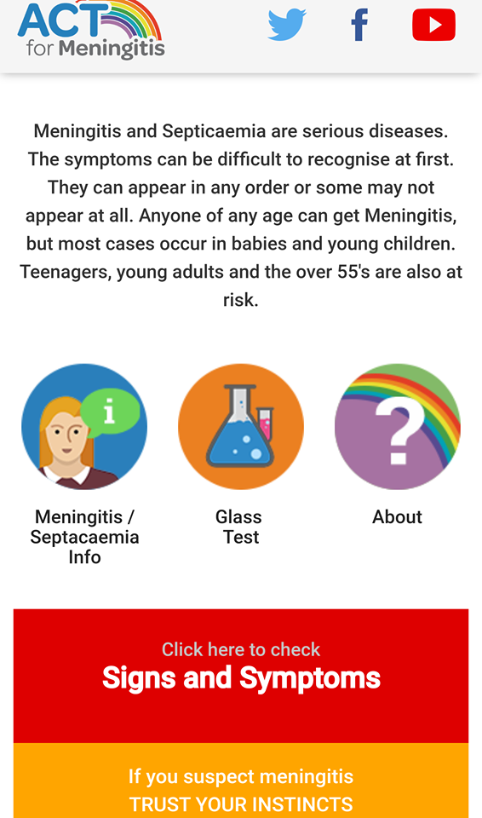
Web development company Digilogue created the app completely free of charge for ACT for Meningitis. This extremely generous donation to the charity has saved ACT a cost of €7,000.

The APP was launched by health and wellness coach, author and motivational speaker Alison Canavan in Dubin in September. Alison was joined by Trevor Durity and Victor Miko from Digilogue and the ACT for Meningitis team.
ACT for Meningitis Lifesaving App is available for download from both Google Play and Apple Store

New Awareness Materials
New awareness leaflets have been designed and are ready for print in the new year; “Home from Hospital” and “Anyone Can Get Meningitis” are three-fold DL information leaflets which, pending funding, will be distributed to all hospitals and healthcare centres during our planned “Healthcare Facility Awareness campaign” in 2017

ACT Awareness Card Now Available As Gaeilge
This year, our meningitis signs and symptoms awareness cards were translated to Irish and distributed to students throughout the Irish Colleges in Connemara!

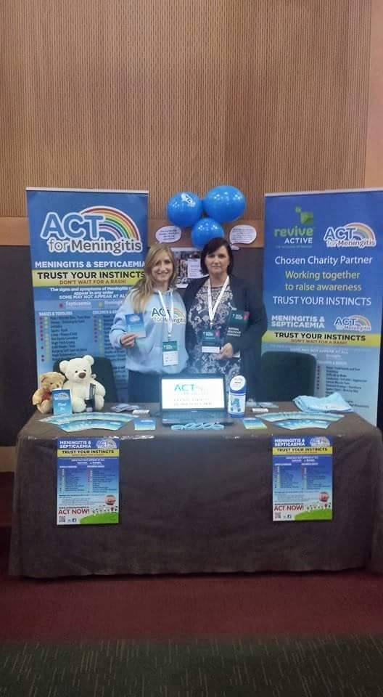

Fundraising 2016
Fundraising for 2016 summed up in one word...Challenging! But we like a good challenge here at ACT and with the phenomenal growth of our support services resulting in a massive 448% increase in cost for 2016 we certainly faced one!
Government grants through the Section 39 Local HSE fund of €1,400 and through the Health Department’s National lottery fund of €10,000 were awarded this year. Although only a fraction of the amounts requested and required, our first successful application for local HSE funding was a very positive outcome in terms of their recognition for the need of our services. We were also relatively pleased to be one of only two successful Galway applicants for National Funding through the lottery funds in 2016. A Corporate grant of €3,107 was also awarded by RSB Community Fund for the purchase of new laptops.

Community Fundraising
Strong corporate partnerships and sponsorship supported our community fundraising this year. ACTion Teds National Pyjamas Party ran from January to March and 68 crèches took part this year.
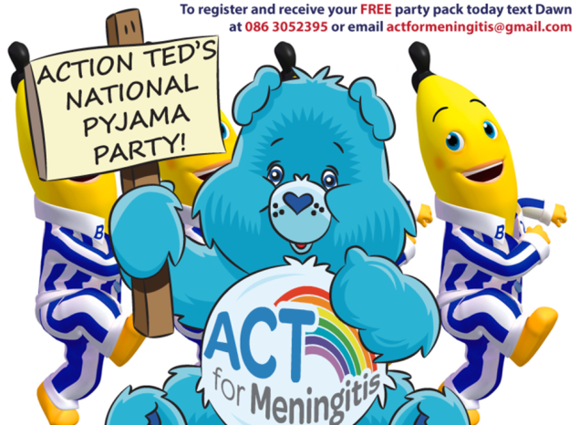
Our annual Remembering Aoibhe 5k and Duathlon which took place in March continues to grow in terms of participants and funds raised and has earned its place on the athletic calendar once again for 2017. Our first annual “Knock Out Meningitis” white collar boxing event was a massive success, and recruitment and training will begin in March with the show set for June next year.
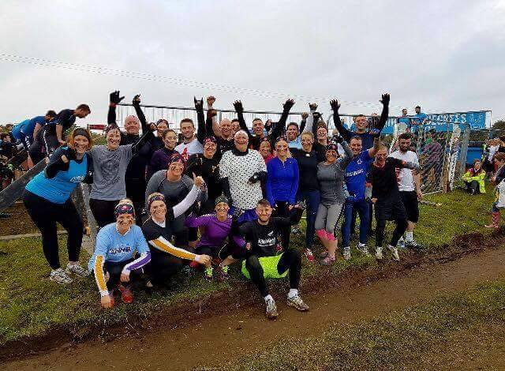
Our 8 weeks to 8k saw a slight decrease this year both in participant and overall fundraising, as a result this will be replaced next year by “Hell & Back with ACT”. This year we had 30 brave participants taking part in a Hell & Back training programme and endurance race, and we plan to double that for next year. November saw the inaugural ACT Winter Ball, a hugely successful fundraiser which is now another firmly placed annual event for ACT.
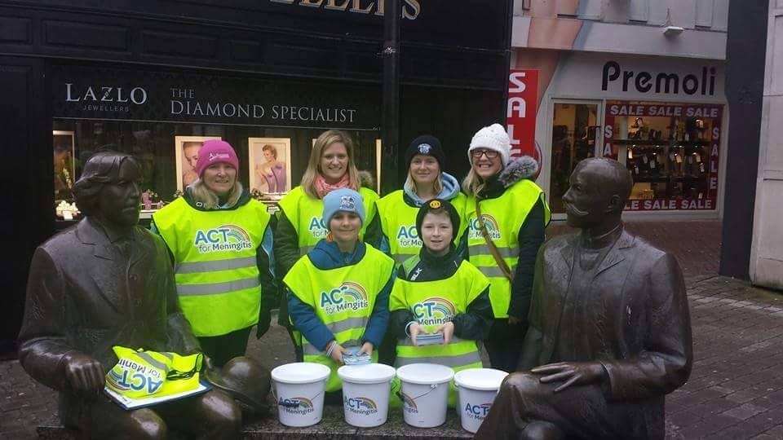

We had a continuous increase in the number of events held in aid of ACT around the country again this year. Mr Waffles Pancake Party, Mark Bolgers Annual Table Quiz, EducoGym Awards Night, Lola’s Ball, Cycle for ACT, Donegals Colour ACT, Challenge Galway Cycle, Siobhan Fitsimons Bake Sale, Millmount Wheelers Cycle, Salthill Zombie Chase, Capellis Hair-Athon, Network Galway Christmas Luncheon and Cuig Phunt Christmas Concert to name but a few! We are so grateful to these wonderful organisations and individuals who continue to support ACT for Meningitis.
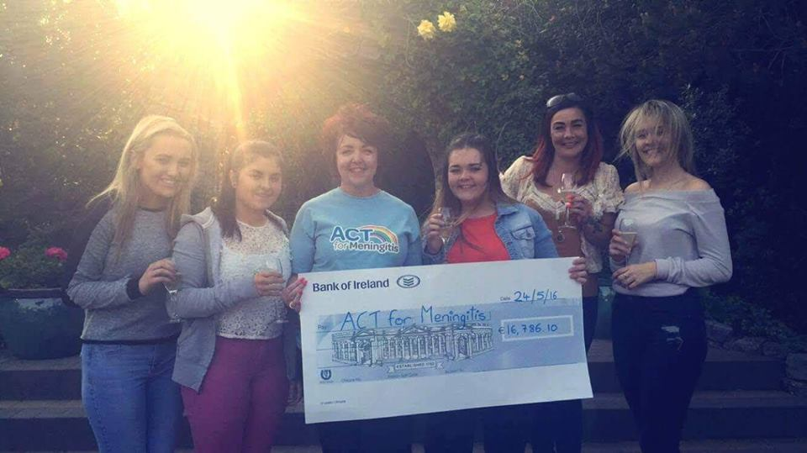

100 Heroes Club
2016 also saw the launch of our first donor acquisition programme, “100 Heroes Club”. The basis of the campaign is to recruit 100 new donors, each donating €21 per month for 12 months to cover the €28,000 our free support services to children will cost in 2017. This initiative which was launched at the ball will be advertised locally and nationally over the coming weeks, both in print and social media.
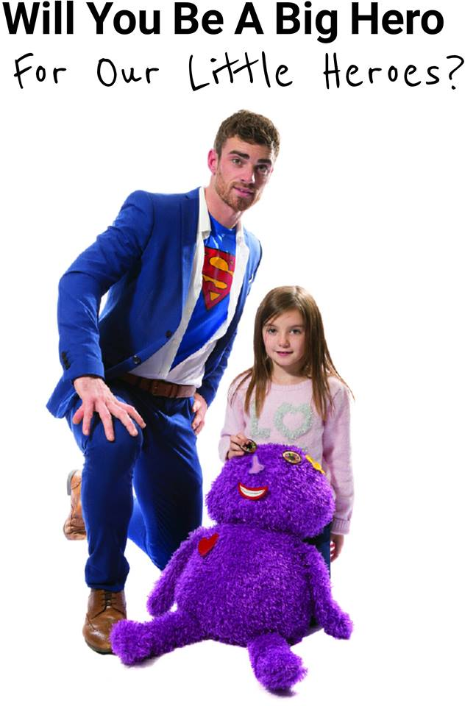
2017’s fundraising calendar is already filling up and as we continue to gain the support of our communities, sponsors, funders and corporate partners, so too will we continue to grow our support services and awareness campaigns and continue to reach out to anyone in Ireland affected by Meningitis.
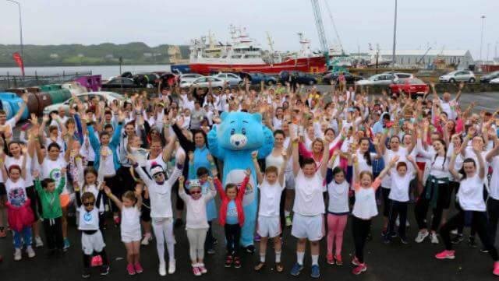

Thank you for supporting ACT for Meningitis in 2016

Support 2016
In 2016 ACT for Meningitis provided support to 56 families, 180 people, availed of our support in 17 counties throughout Ireland, adding 7 families and 2 counties to our existing support reach.
Eight children availed of Play Therapy this year, 1 child accessed an Occupational Therapy assessment and 2 adults accessed counselling.
In 2016 we had a change of venue for the Summer Family Support Day to Dublin zoo, 11 families attended and enjoyed the day and the workshops facilitated which were themed to introduce playfulness back into relationships and build on existing family strengths.
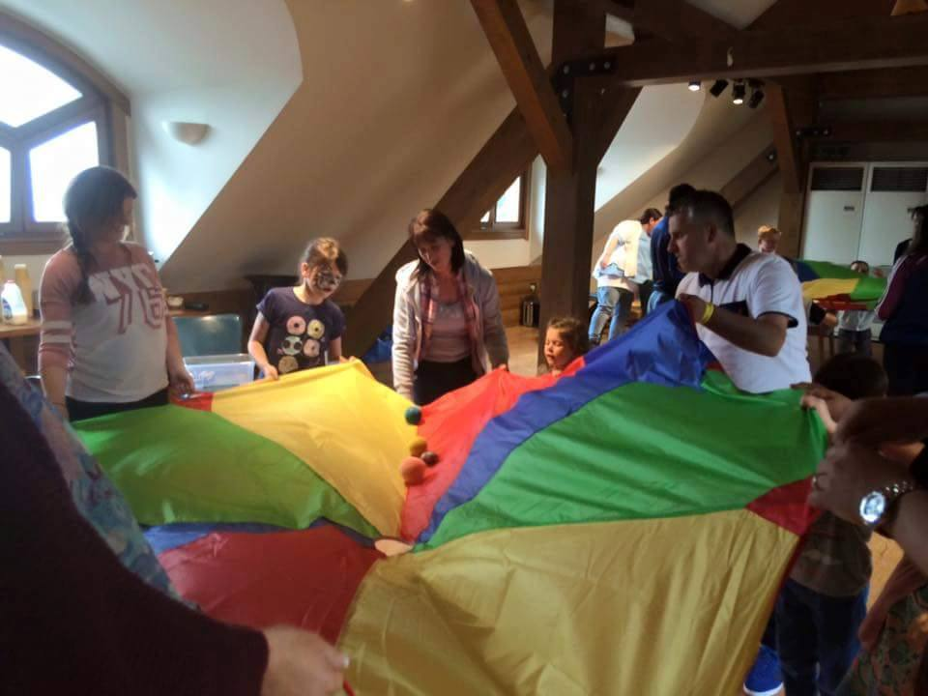

ACT for Meningitis hosted the first Remembrance Day in the Dublin this year. The day consisted of a Mindfulness group, an Art Therapy group and a Talking Therapy group over 7 hours.
A Family who had lost a daughter to Meningitis, over 20 years ago told us about how they had never spoken so honestly or freely about the loss together.
Act for Meningitis launched two new workshops this year, we ran our first series of Reconnecting after Meningitis workshops. These workshops are aimed to run both in Galway and nationally with families who have been affected by Meningitis. The Galway series of workshops were completed in 2016. The aim of these workshops is to help overcome the trauma which the families have been through. In some families it may be a child or a parent who has experienced meningitis or a family who has been bereaved. In each case the family dynamics have changed and the workshop focuses on rebuilding the attachment and focusing on the positives within the family, to strengthen and empower families through play and fun. Families provided very positive feedback.
In April we started our first bespoke course entitled “You, Your thoughts and Your ACTions”. This was a nine week course, designed for and delivered to adults who were coping with the after effects of Meningitis. This first course ran in Galway and we are currently in the process of securing funding in order to roll out an adapted format in National locations.
The course was open to parents of children who had Meningitis, people who had been bereaved by Meningitis and adult survivors of Meningitis.
The course explored stress and anxiety and the part it plays in our lives, while also giving the opportunity to practice how different mindfulness practices like mindful yoga, sitting meditation and body scanning help to reduce stress.
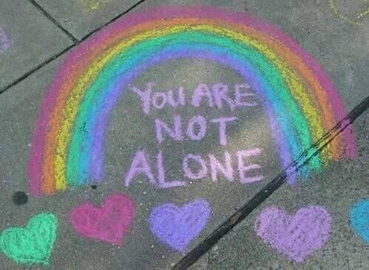
Part of the course incorporated Cognitive Behavioural Therapy techniques to explore the causes of our stress and our stress reaction systems alongside exploring the neuroscience of stress – what is happening in the brain? How do we combat it? Participants explored techniques and developed resourcing strategies to enable them to address stress , anxiety and their causes within their lives. An important element of the group was also peer support and a non-judgemental space to share personal experiences with people who had been through similar situations. As one participant said “ to be understood and accepted by others who knew what it was like”
Some other feedback included:
“ I have thoroughly enjoyed the course, it offered excellent advice”

“The course offered practical examples that I can use to reduce stress and anxiety and identify coping strategies”

“I have listened and learned from other people’s life stories and now understand my child’s problems with better clarity”

“ I found it very beneficial and I am taking a lot away with me”

Having the opportunity to expand the range of support services we offer to families has had a hugely beneficial impact to the families who have availed of them. Feedback that includes people feeling they are no longer alone and more able to face their journey to recovery as well as feeling more connected and empowered as family units tells us we are having the desired impact on the lives of the families we seek to support. Through collaboration with families who use the service we have prioritised two new services we hope to introduce in 2017. We plan to begin 6 weekly support meetings for families to attend and access a supportive space not only with the Family Support Officer but also with others who have been through the same or similar experiences.
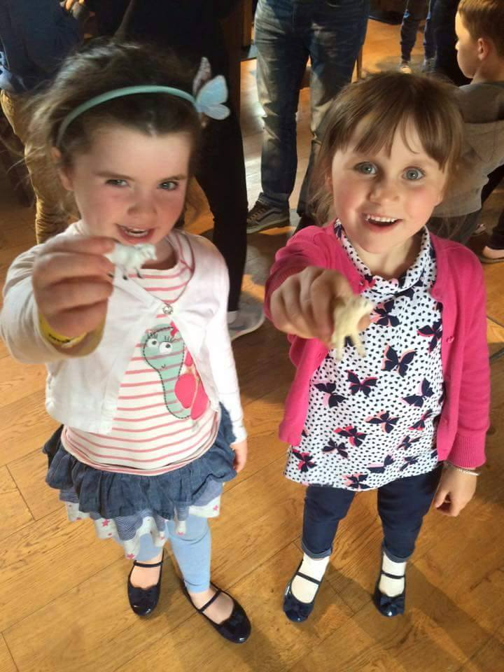
We also plan in Summer 2017 to run a summer camp programme for the siblings of those affected by Meningitis, to support their experience of life after meningitis and the changes that this has brought to their lives. Initial planning is in progress.
2016 Financial Report
Income for 2016
Our income this year was €134,937.14. Once again a positive improvement on last year’s figure, despite the reduction in grant aid received. Our community fundraising events were very successful and the increase in “in aid of” events also attributed to this increase. The cost of our free services provided has grown by 448% in the last 12 months and without the continued support from the public, corporate sector and grants received, we would struggle to continue to reach out to new families and individuals across the country with these services. . As our charity continues to grow, we endeavour to find ways to generate funds for our support services and life-saving awareness campaigns.

Expenditure for 2016
Our expenditure this year was €156,238. This is higher than last year, due to the growth of the charity and the increase in families we support nationally. In 2016 ACT for Meningitis provided support to 56 families, 180 people, availed of our support in 17 counties throughout Ireland. Our national awareness campaigns and free education services also continue to grow and as an organisation we will continue to seek more efficient means of raising awareness and education, whilst providing our support services.
Audited Accounts 2015

